The Politics of Food Security

Office Hours: Tuesday 2-4pm
Office: Watson 317
Michelle_Jurkovich@brown.edu
Professor Michelle Jurkovich
Spring 2015
Tuesdays 4-6:30pm
JWW 401

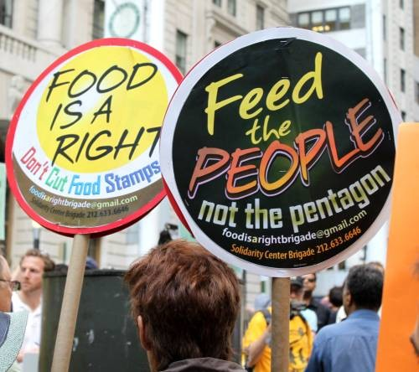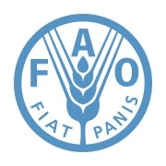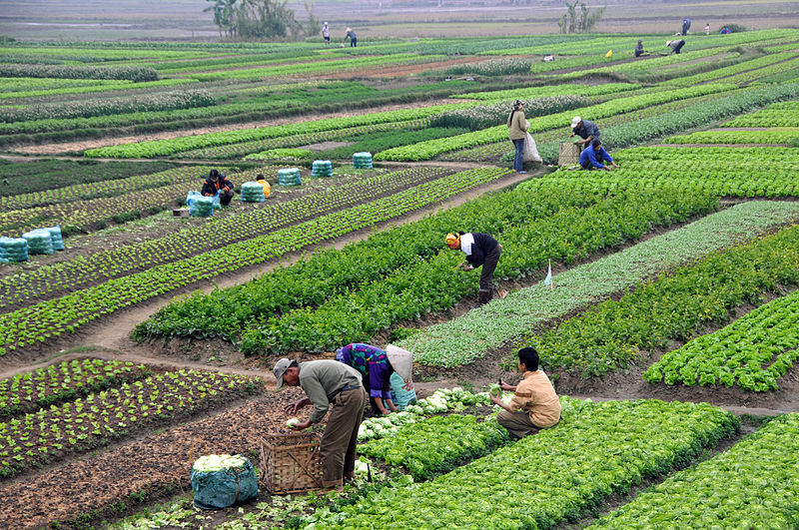

Course Description
There is enough food on the planet to feed everyone, and yet currently approximately 875 million people go hungry. Why is this the case? This course explores the politics of international food security, dividing the semester into four sections to examine food through the lens of development, human rights, governance, and security concerns.

Our weekly discussions will focus on questions such as: Who governs food security? Why and how have states responded to global hunger? What does domestic and international activism look like in this issue area? Is food security a development problem or a human rights problem? What happens when these approaches clash? Does food insecurity encourage domestic instability? Our readings for this course will highlight key debates around food security, including contemporary debates on questions of GMOs and the “buy local” movement as these affect broader human rights and development goals.

Course Goals

The goal of this course is to:
- Enable students to think (and write) critically on the topic of international food security
- Provide students with on overview of historical and contemporary debates in the issue area
- Encourage students to think analytically about how the issue of food security can affect broader theoretical conversations (especially in the field of international relations)
- Enable students to think clearly about complex debates in food security and engage in critical debate on these topics in a concise and constructive way

Course Outcomes

At the end of the semester, students should be able to:
- Understand the contours of key international food security debates and think critically about them
- Understand where to look (i.e. identify primary and secondary sources) when investigating questions of food security
- Conduct original research and write a well-developed research paper with analytic depth
- Convey complex ideas in a clear and concise way and engage in critical debate

Class Policies

Special accommodations: Please see me or email me in the first two weeks of class if you require any special accommodations due to learning disabilities, religious practices, physical or medical needs, athletic commitments, or for any other reason.

Academic integrity: I do not tolerate any academic dishonesty. The University’s Academic & Student Conduct Code can be found here: http://www.brown.edu/Administration/Dean_of_the_College/curriculum/documents/principles.pdf. Ignorance is not an excuse. Please consult with me if you are in doubt about what constitutes academic dishonesty.

Late Assignments: Please turn in your assignments on time. Late assignments will be penalized ½ letter grade per day late. Exceptions will be made only in serious circumstances, and will require documentation of the emergency from a person of authority.

Attendance Policy: This is a discussion-based course, and as such attending each class session is extremely important. You are permitted one (1) unexcused absence during the term. All other unexcused absences will result in penalties in your attendance/participation grade. Documentation must be provided for excused absences.

The Writing Center: The Writing Center is available on campus (at no cost) to help you with your writing. They provide one-on-one tutoring and are happy to read through drafts of your work and provide useful feedback. They are located in J. Walter Wilson Room 213, and appointments can be made online. Visit http://www.brown.edu/academics/college/support/writing-center/.

Readings:

This course has nine required books.
*Indicates the book is available electronically through Brown’s library (via Josiah)

*Jennifer Clapp and Marc Cohen (Eds.): The Global Food Crisis: Governance Challenges and
Opportunities (2009)
*Nicholas Cullather: The Hungry World: America's Cold War Battle Against
Poverty in Asia (2013)
*Alex deWaal: Famine that Kills (2005)
Sam Hickey and Diana Mitlin (Eds). Rights-Based Approaches to Development
Francis Lappe et al: World Hunger: Twelve Myths (1998)
*Robert Paarlberg: Starved for Science (2009)
*Robert Paarlberg: Food Politics: What Everyone Needs to Know (2010)
Amartya Sen: Poverty and Famines (1983)
Amartya Sen: Development as Freedom (1999)

These texts can be purchased in the Brown bookstore or online. Alternatively, I will place a copy on reserve at the Rockefeller library.

All other readings will be posted to OCRA.

Assignments and Grading:

- Attendance/Participation in class blog: 30% total
  - Attendance in class and active participation (15%)
  - Comments to the class blog (15%): Each week, a new discussion question will be posted to the class blog, generally related to the weekly readings. Students are expected to provide an insightful comment by Monday at 5pm each week. Our class blog is: http://politicsoffoodsecurity.weebly.com/
- Event Reflection Paper (two pages, double-spaced) and Presentation: 15%. Providence and Boston have active food & social justice communities, where there are many food security related lectures, protests, and events taking place. For your event reflection paper you will attend one food security event of your choice and write a short, two-page (double-spaced) reflection paper tying your experience to something we have discussed in lecture or read in class. Perhaps your event sheds light on questions raised in class? Or perhaps it contradicts a point made by one of the authors we read? These would be welcomed discussions in your paper. Please see me if you have difficulty choosing an event to attend. These can be lectures by activists or scholars, protests, or government debates or NGO events surrounding a particular food security issue. This paper can be submitted at any class meeting before April 28, with the presentation happening the day you submit your paper. Presentations will be brief (5 minutes) and allow time for questions.
- Memo & Leading Class Discussion: 20% (10% for handout, 10% for presentation). Each course meeting will be kicked off by a brief presentation (5-10 minutes) from 1-2 students who will be guiding our discussion on the readings that week. In addition, when it is your week to lead discussion, come to class with a 1-2 page discussion memo where you analyze and engage with the readings for that week. These are more than mere summaries of the assigned readings. How do the readings relate to other readings we have done? What do we gain from the perspectives provided by the authors? What might the authors be omitting? Bring enough hard copies of this memo to distribute to the entire class.
- Final Research Paper (~ 20 pages double-spaced), final version due in hard copy in my mailbox (second floor of Watson) by 5pm Friday, MAY 8: 25% (a total of 35% when including the proposal and draft).
*When submitted, your final paper should be stapled to your paper draft.
  - Paper proposal (1-2 pages, double spaced): Due in class on March 10: 5%.
  - Paper draft for peer review (minimum of 5 pages): Tuesday, April 21: 5%.
-Bring a hard copy of your paper to class for peer review.

Topic and Reading Schedule:
Readings need to be completed prior to the start of class for the date they are listed.

January 27: CLASS CANCELLED DUE TO BLIZZARD

February 3: Introduction to the Course & What is Food Security? Part 1
Francis Lappe et al: World Hunger: Twelve Myths (entire book, 224 pgs)

February 10: What is Food Security? Part 2
Robert Paarlberg: Food Politics: What Everyone Needs to Know: Chapters 1-5 (pp. 1-55) & 7-
10 (pp. 70-126).
Final Report and Action Plan from the 1996 World Food Summit (available from the FAO
website at: http://www.fao.org/wfs/index_en.htm)
Amy Staples (2006). The Birth of Development: How the World Bank, Food and Agriculture
Organization, and the World Health Organization Changed the World, 1945-1965 (Chps 5-7, on OCRA).

Food Security as a Governance Issue

February 17: University “Long Weekend”---no class

February 24: What do governments have to do with food security?
Amartya Sen: Poverty and Famines (entire book, 270 pages)

March 3: Who governs international food security?
Jennifer Clapp and Marc Cohen (Eds.): The Global Food Crisis: Governance Challenges and
Opportunities (2009) (entire book, 288 pages)

Food Security as a Security Issue

March 10: Food aid and psychological warfare: Winning hearts and minds?
Nicholas Cullather: The Hungry World: America's Cold War Battle Against
Poverty in Asia (entire book, pp. 1-272).
Does food insecurity lead to domestic instability?
Cullen Hendrix & Henk-Jan Brinkman (2013), "Food Insecurity and Conflict
Dynamics: Causal Linkages and Complex Feedbacks" (on OCRA)

Food Security as a Development Issue

March 17: Famine, Food Aid, and the Green Revolution
Alex deWaal: Famine that Kills (entire book, 244 pages)
Chris Barrett & Daniel Maxwell (2004), “Policy Brief: Recasting Food Aid’s Role” (on
OCRA, pp. 1-6).
Robert Paarlberg: Food Politics: What Everyone Needs to Know: Chapter 6 (pp. 56-69)

March 24: SPRING BREAK

March 31: The Capabilities Approach
Amartya Sen: Development as Freedom (entire book, pp. 1-298)

Food Security as a Rights Issue

April 7: When Rights and Development Clash
Sam Hickey & Diana Mitlin: Rights-Based Approaches to Development (entire book, pp. 1-
230).

April 14: Economic and Social Rights
Universal Declaration of Human Rights (available online at:
http://www.un.org/en/documents/udhr/history.shtml)
Callaway & Harrleson-Stepens, Sections 1.2, 1.3, & 1.4. These include excerpts of work by
Henry Shue (“Basic Rights”) and David Beetham (“What future for
economic and social rights?” (available on OCRA)
Ziegler et al, The Fight for the Right to Food: Lessons Learned (pp.1-22, on OCRA)

April 21: Rights Activism
Kenneth Roth (2004), “Defending economic, social and cultural rights: Practical issues
faced by an international human rights organization,” pp.63-73 (on OCRA)
Margaret Keck & Kathryn Sikkink (1998). Activists beyond borders: Advocacy networks in
international politics. Cornell University Press, pp. 1-38 (on OCRA)
Food Security: Hot Topics

April 28: GMOs and the Organic Revolution
Robert Paarlberg: Starved for Science (entire book, 256 pages)
Robert Paarlberg: Food Politics, pp. 155-173.
Kenneth Chang (2012) “Study Questions Advantages of Organic Meat and Produce,”
NYTimes (2 pgs, on OCRA).
Mark Bittman (2012) “That Flawed Stanford Study,” NYTimes (2pgs, on OCRA).

March 5: Buy Local?
Robert Paarlberg: Food Politics (Chps 11-2, pp. 127-154)
Budiansky (2010) “Math Lessons for Locavores” NY Times op-ed (on OCRA)
“Do Locavores Really Need Math Lessons?” collection of responses to the Budiansky’s op-
ed. Available at: http://grist.org/article/food-fight-do-locavores-really-need-math-lessons/full/ (also, on OCRA)

**NOTE: This syllabus is a living document and is subject to change by the instructor at any point.

